Evidence Questions(2) on JavaScript

*IDB-BISEW IT Scholarship Project*

*Batch ID: WDPF/TCLD-A/47/01*

*Instructor Name: Syed Ziaul Habib*

1. Create an html document to find Prime of a given number (n!) where the number is taken from user.

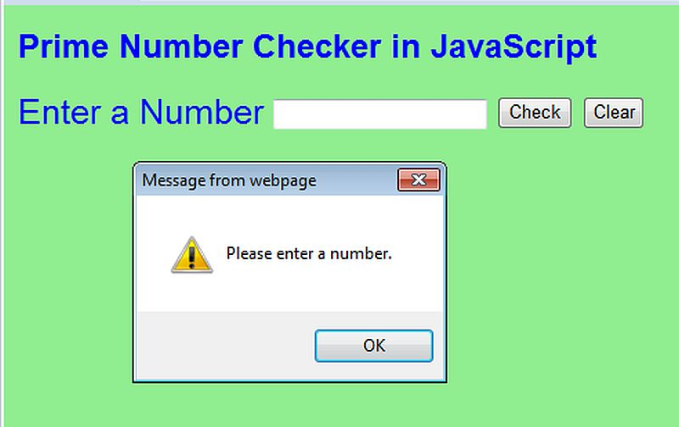

1. Create a login form and check the following validation using JavaScript:
2. Email address with valid structure.
3. Password is minimum 6 characters long.

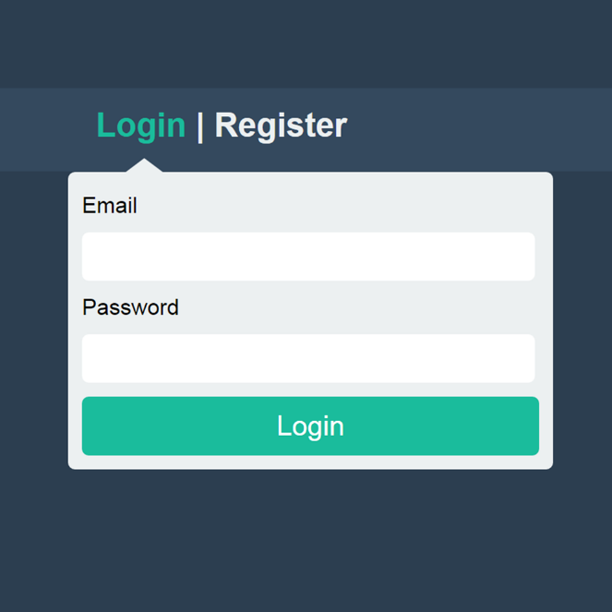

1. Create an html document with a student entry form. All fields are must be filled out. Apply JavaScript validation for each field. After validation preview them in a new window.

